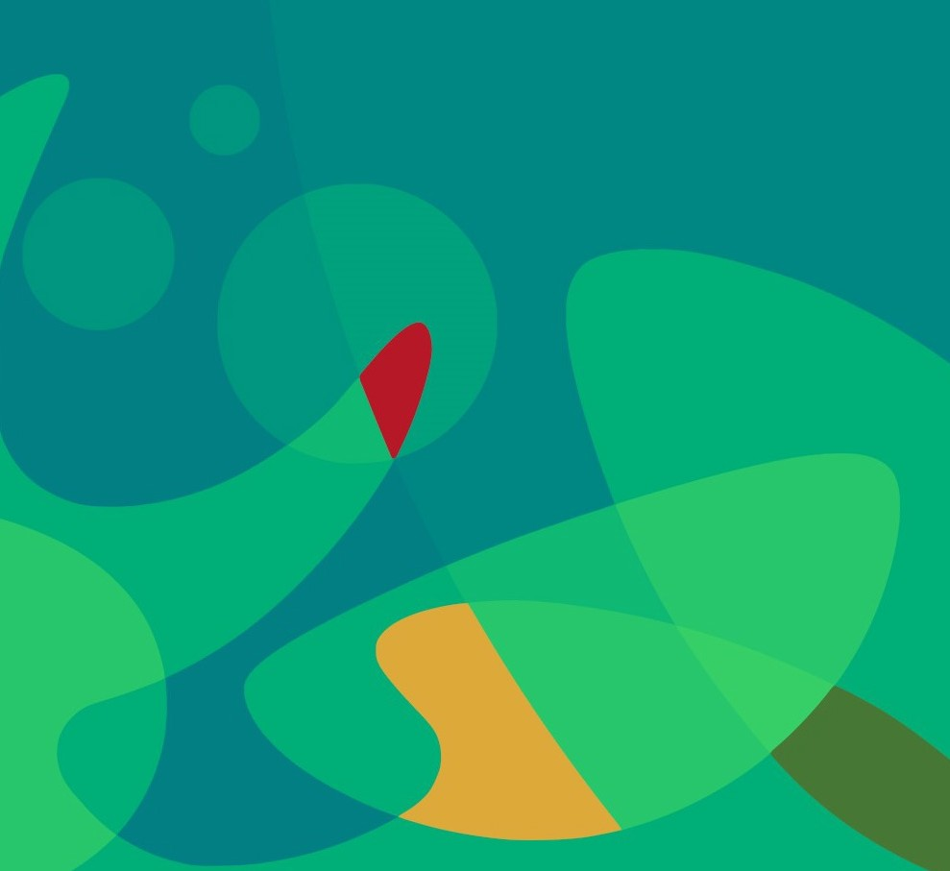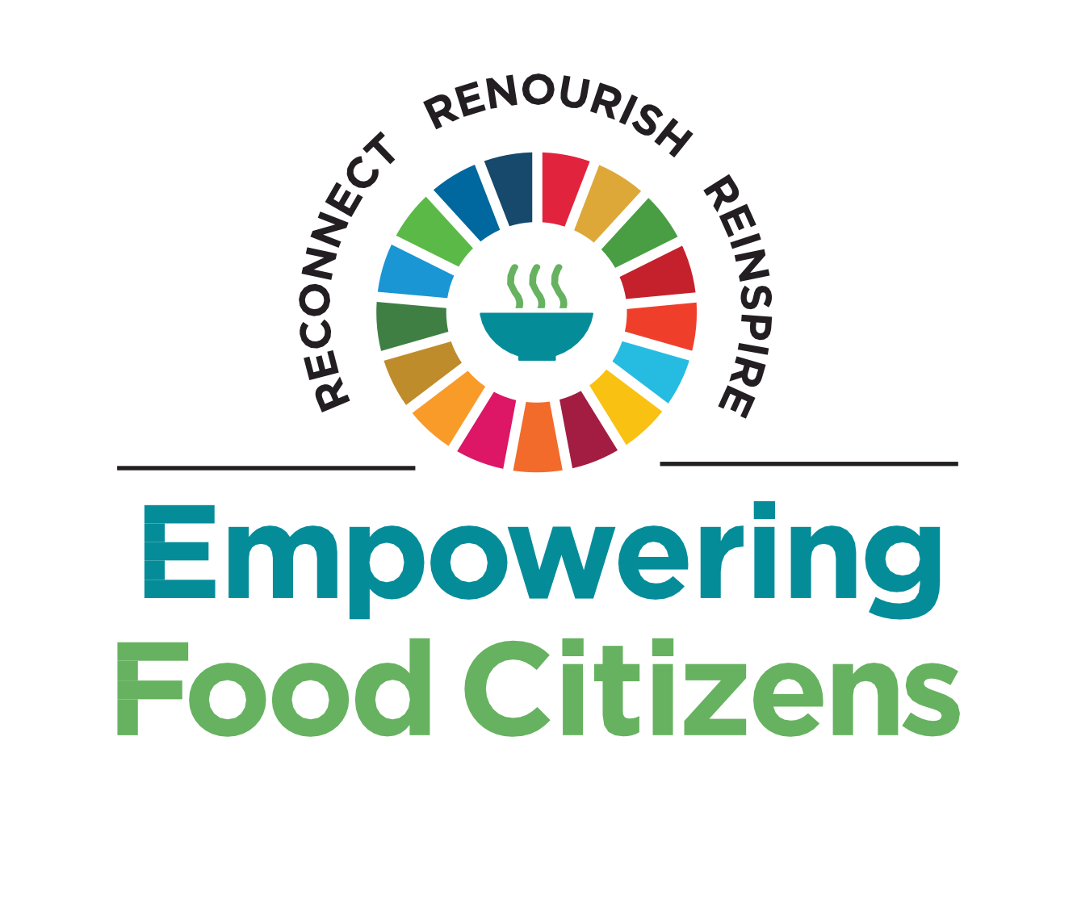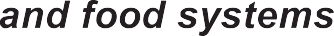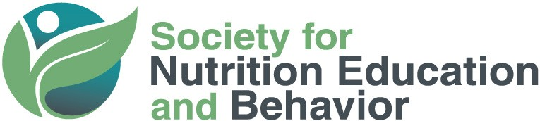

July 20 - 23, 2023
SNEB INTERNATIONAL CONFERENCE

SPEAKER COMMUNICATION TOOLKIT

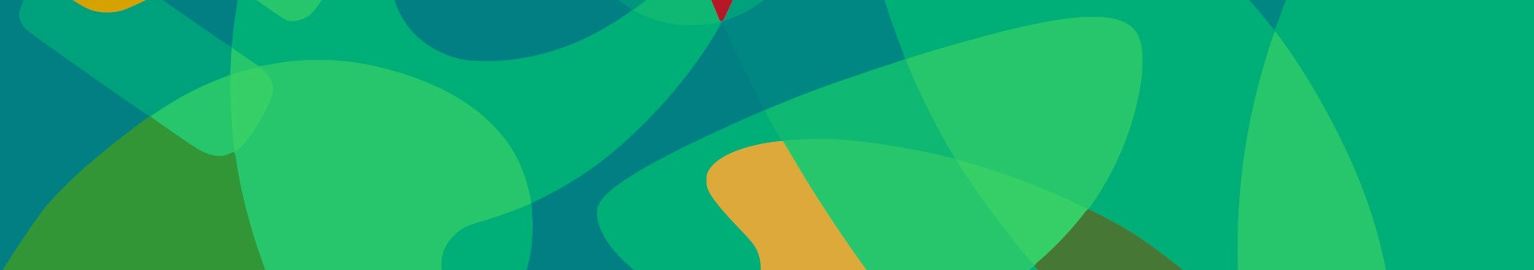
SNEB 2023 means coming together July 20-23 in Washington, DC but also connecting with virtual attendees from
around the globe. Help us share that inclusive message!

Below is a sample copy you can post on social media outlets, send to colleagues via email, or distribute to institutional and local news outlets, including real or virtual departmental bulletin boards. Simply insert appropriate information about your session or workshop (including dates and times) when spreading the word. By joining together to encourage colleagues and students to attend, we can make this a great event!
Conference Web Link
The link to SNEB's International Conference website is sneb.org/sneb-2023. It's hyperlinked in all the sample text below. You can also include it in URL format in any promotional materials you circulate.
Social Media
The official conference hashtag is #SNEB2023. Be sure to include this in all of your conference messaging on social media. Like and follow us on Facebook and Twitter @SNEBonline. Images you can use along with your messaging are attached.
Facebook Profiles and Group Pages Sample Text

Nutrition educators and professionals, I'll be presenting at the @SNEBonline 2023 International Conference, Empowering Food Citizens: Together for Nutrition and Food Systems Transformation. My topic is [add topic/title here and whatever you want to say about it.] I'd love to see you there! Like and follow SNEB: http://www.facebook.com/SNEBonline #SNEB2023.

[Tips]: Post often for maximum exposure. Let others know how important SNEB's International Conference is and what they'll gain from attending. In multiple posts, include tidbits, significant research, or other info about the topic you'll be presenting. Are you sharing new findings? Send a teaser but tell them they have to attend to hear "the rest of the story."
SNEB2023
EMPOWERING FOOD CITIZENS

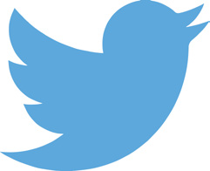
Twitter
I will be presenting at #SNEB2023 this July 20-23 in Washington, DC. Join me for my session on [brief details about your session]. Register Now: sneb.org/sneb-2023 @SNEBonline.
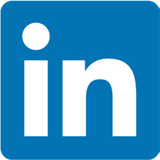
LinkedIn
Join me at the Society for Nutrition Education and Behavior 2023 International Conference, Empowering Food Citizens. I will be presenting a session on [details about your session]. I hope to see you there! To register and learn more about #SNEB2023, visit sneb.org/sneb-2023.
Personal Web Sites / Blogs

If you maintain a personal website or blog, here are some idea starters for a conference-related post:

- Talk about your presentation and invite comments on your post
•Have you published a book or other resource people might be interested in?
•Is your topic a hot one? Open up the debate!
•Create a contest or incentive for people who read your content and then attend your session

You can also create a video. Nothing is more compelling than seeing and hearing someone passionate about their topic. Send a copy of your video to info@sneb.org and we’ll help you share.
Emails to Colleagues and / or Students

Dear Colleagues/Students,

For more than 50 years, the Society for Nutrition Education and Behavior (SNEB) has hosted the only event specifically for nutrition educators. I'm proud to announce I'll be presenting a [session/ abstract] on [add topic/title] as part of 2023 SNEB International Conference, Empowering Food Citizens: Together for Nutrition and Food Systems Transformation, July 20-23. I invite you to come to my session on [date, time].

Don’t miss a great opportunity in Washington, DC to learn about new research, creative ideas, and practical techniques applicable in many settings. This year's conference is in-person with livestream- ing sessions. The conference is offering 24 CEU credits that are valid for three years.

So, please join me at the SNEB 2023 International Conference. Details are online at sneb.org/ sneb-2023. Forward this email to anyone else you know who might be interested.

Thanks, and I hope you can join me!
Departmental Online Bulletin Boards and Calendars

The Society for Nutrition Education and Behavior (SNEB) International Conference is the premier event for nutrition education professionals from around the world.

[Insert Your Name] is one of the conference presenters speaking on [Insert Topic]. [Add additional facts about your presentation as appropriate].

The 2023 event is themed "Empowering Food Citizens" and will be held in-person in Washington, DC and online from July 20-23. For more information, visit sneb.org/sneb-2023.
School, University, or Business News Outlets and / or Web Sites

FOR IMMEDIATE RELEASE

[Your name] will present on [your topic] at the Society for Nutrition Education and Behavior (SNEB) 2023 International Conference, Empowering Food Citizens: Together for Nutrition and Food Systems Transformation hosted in-person in Washington, DC and online from July 20-23.

[Add information about yourself, your title and position, and your work. Include how your technique, findings, or other product promote nutrition, healthy communities or improve healthful behaviors].

SNEB's conference is the only event specifically for nutrition educators. SNEB is an international organization of nutrition education professionals who are dedicated to promoting effective nutrition education and communication to support and improve healthful behaviors with a vision of healthy communities through nutrition education and advocacy. For more information, contact SNEB at 800-235-6690 (317-328-4627 outside the U.S.) or sneb.org/sneb-2023.

-End-

[Tips]: Send this to your school or university press office for publication in their faculty news re- sources and in the school paper. You don't have to write much copy, just include a few sentences of the most important and/or interesting news - enough to encourage the news outlet to contact you for more information and an interview. They will write the rest. Be sure to include the closing para- graph about the conference and SNEB.

Local News Outlets

FOR IMMEDIATE RELEASE

[Open your press release with an anecdote related to your presentation topic or more broadly with an anecdote about your work. Include compelling information about your topic such as new research findings, the importance of nutrition education and how it directly affects your community. Have you implemented a unique nutrition education program in your school, university, or commu- nity? In what way does your technique, findings, or other product promote healthy communities or improve healthful behaviors? Add it to this press release then tie it in with conference and the fact that you will be there to present on this exciting topic. Include your title and position].

[Your name] will present on [your topic] at the Society for Nutrition Education and Behavior (SNEB) 2023 International Conference, “Empowering Food Citizens" hosted in-person in Washington, DC and online from July 20-23.

This is the only event that is specifically for nutrition educators. SNEB is an international organization of nutrition education professionals who are dedicated to promoting effective nutrition education and communication to support and improve healthful behaviors with a vision of healthy communities through nutrition education and advocacy. For more information, contact SNEB at 800-235-6690 (317-328-4627 outside the U.S.) or visit sneb.org/sneb-2023.

[Tips]: Send this to your local news outlets: TV, radio and newspapers, which are always in the market for local interest stories. Don't forget niche publications like business journals and educa- tion-focused nonprofit news organizations. You don't have to write much copy, just include a few sentences of the most important and/or interesting news – enough to encourage the news outlet to contact you for more information and an interview. They will write the rest. Be sure to include the closing paragraph about the conference and SNEB.

GRAPHICS:

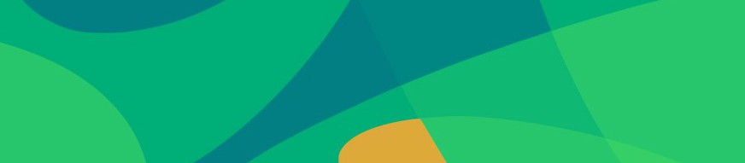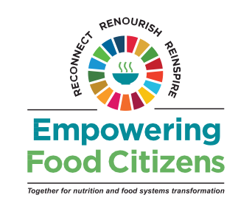
SNEB2023
SNEB.ORG

